Build and Operate Enterprise Multi-Agent AI Systems at Scale with AWS and Datadog-Virtual

- Pluggable Agentic AI Framework on Amazon Bedrock AgentCore
- Prerequisites
- AWS-only base implementation
- AWS + Datadog Implementation
- Workshop Cleanup
- Workshop Contributors
- Summary
AWS account access
Open AWS console
(us-west-2)
Get AWS CLI credentials

Pluggable Agentic AI Framework on Amazon Bedrock AgentCore
Build, Deploy & Operate Agentic AI Systems at Scale with AWS and Partners
Enterprises are moving from AI experimentation to AI operations, and the gap between a prototype that works in a notebook and an agent system that runs reliably and securely at scale is where most initiatives stall. Teams hit escalating cost, inadequate risk controls, and unclear business value — often within weeks of launch. This is not a capability problem. It is an architecture problem.
The organizations that succeed treat agentic AI as a distributed system, not an AI experiment: with stable layer contracts, bounded autonomy, structural security, and observability from day one. This workshop, built in partnership with AWS and its partners, provides the Enterprise AgenticAI Reference Architecture and working code to close that gap.
The workshop is built around AnyCompany, a fictional online retailer, using the supervisor–specialist sub-agent pattern on Amazon Bedrock AgentCore. Participants ground knowledge in a vector store and a structured database, build a pluggable inference layer, orchestrate specialist Order and Refund agents through an Amazon Bedrock AgentCore Harness supervisor and Amazon Bedrock AgentCore Registry, enforce guardrails against prompt injection with Amazon Bedrock Guardrails, and monitor operations with AWS X-Ray and Amazon CloudWatch GenAI Observability.

Table of Contents

- Customer challenges in operating agents in production
- Design Principles for Production Agentic Systems
- Pluggable Agentic AI Framework - Enterprise Agentic AI Reference Architecture with the Seven Layer Contracts
- Use Case for this workshop
- AWS and Partner Extensions
- Prerequisites
- Who This Workshop Is For
- Workshop Modules
- Supported Regions
- Cost
- Cleanup

Customer challenges in operating agents in production
The majority of enterprise AI agent initiatives follow a familiar pattern: fast prototype, slow production. The friction points are consistent across industries and team sizes, and they compound across four phases of the agent lifecycle. Each pain point below is listed in the phase where it first blocks progress — even though its consequences often propagate to later phases.
A representative story. A retail team ships a customer-support agent that answers policy questions accurately in dev. Two weeks after launch, token spend is 12× forecast, P95 latency has crossed 8 seconds, and CSAT has quietly dropped 4 points — with no alert firing. The root cause is not the model. It is the absence of routing, observability, and evaluation as first-class architectural components.

Build — Getting to a working agent

- Framework fragmentation — Teams re-platform mid-project as they outgrow their initial choice; skills and code do not transfer across LangChain, LangGraph, CrewAI, AutoGen, and Strands.
- Goal and behavior design — Defining reliable goals and expected behaviors for non-deterministic systems is hard, and traditional requirements documents do not capture emergent behavior.
- Grounding and RAG quality — Chunking, embedding-model choice, and retrieval tuning are opaque without structured guidance, so agents fabricate when foundation-model knowledge is incomplete.
- Tool proliferation — Single-agent designs loaded with many tools degrade reasoning quality, and tool schemas, errors, and side effects are hard to manage as the tool count grows.
- Multimodal input handling — Vision, audio, and document inputs are treated as edge cases rather than first-class inputs.
- Memory architecture — When to use session, long-term, or semantic memory is poorly understood at design time, and the choice is expensive to reverse once sessions and agents accumulate state.
- Evaluation strategy — Traditional unit tests do not work for emergent, probabilistic behavior, so teams ship without a viable test strategy for either launch quality or ongoing regressions.
The result: teams ship prototypes they cannot maintain, extend, or trust in production.

Deploy — Moving to production

- Cold-start latency — Agent endpoints that spike to 5–15 seconds on first request are unacceptable for customer-facing applications.
- Model serving complexity — Self-managed inference requires GPU expertise most AI teams lack, and no standard exists for right-sizing serving infrastructure to workload shape.
- Environment parity — Agent behavior in dev rarely matches production due to data, latency, and permission differences across multiple services, models, and dependencies.
- Security posture — PII exposure, prompt injection, tool access scoping, and guardrail configuration are discovered post-launch rather than designed pre-launch.
- Model and provider routing — Selecting the right model per task and balancing cost, latency, and quality is done ad hoc.
- Versioning and rollback — No standardized approach to agent versioning, rollback, or A/B deployment across multi-agent systems.
The result: launch is delayed by months, or the agent goes live with hidden operational and security risk.

Operate — Running at scale

- Observability blind spots — Traditional APM tools do not understand LLM calls, token budgets, GPU pressure, or multi-hop agent traces, so latency, cost, and quality issues cannot be correlated across 4–6 specialist agents.
- Cost runaway — Routing all traffic to premium models drives 10–50× the necessary cost, and no feedback loop surfaces this until the invoice arrives.
- Silent quality degradation — Hallucination rate or CSAT can drop week-over-week without any alert firing, because ongoing regression evaluation was never wired up.
- Human-in-the-loop escalation — Knowing when and how to escalate to humans is rarely codified, so either everything escalates or nothing does.
The result: cost, quality, and reliability degrade silently — and customers, not dashboards, discover the problem first.

Scale — Growing the platform

- Agent registry gaps — No canonical way to catalog, discover, and govern agents across teams and use cases.
- Compute elasticity — CPU-based inference and single-tenant GPU fleets cannot sustain concurrent multi-agent workloads at enterprise volume.
- Reliability and resilience — Handling partial failures and preventing cascading errors across a fleet of agents requires explicit design, not hopeful retries.
- Governance and compliance — Meeting regulatory, audit, and data-residency requirements becomes harder with every new use case built on a different pattern.
- Partner integration risk — The vendor-lock-in vs. openness trade-off is unresolved at architecture time, so second-choice swaps are expensive.
- Organizational readiness — MLOps, platform, and product teams lack a shared vocabulary and reference model, so every new use case starts from zero.
The result: the second and third use cases cost as much to build as the first, and the platform never compounds.

Design Principles for Production Agentic Systems

The problems in the previous section share a root cause: agentic AI is being built as a collection of tools rather than as a system. Tools and technologies are the means to implement an architecture — they are not a substitute for one. Enterprises that operate agents at scale converge on the same five principles, drawn from distributed systems, contract- first API design, and the emerging discipline of AgentOps.
Two definitions are used throughout this document:
- Contract — a declared, stable interface between components, expressed as a schema, tool spec, agent card, or API definition. Contracts are versioned; implementations behind them are free to change without breaking callers.
- Structural — a capability that is applied uniformly across every agent from the first line of code, not added later as an overlay. Structural capabilities cannot be opted out of at the component level.

The five principles

1. Loose Coupling Through Stable Layer Contracts Each functional component exposes a stable contract; behind that contract, the implementation is free to change.
- Addresses: framework fragmentation, version management, partner integration risk.
- Trade-off: modest versioning overhead and one extra hop of indirection at runtime.
2. Bounded Autonomy Supervisors route; specialists execute within a scoped tool set and a defined success criterion. Each specialist fails, scales, and improves independently, which prevents scope creep from undermining the multi-agent system.
- Addresses: tool proliferation, cascading failures, human-in-the-loop escalation.
- Reinforces: Security as a Structural Layer — a scoped tool set with least-privilege permissions is what makes guardrails, identity, and PII controls enforceable at runtime. Bounded autonomy directly mitigates OWASP LLM06 (Excessive Agency)¹ by capping the blast radius of any single specialist and by giving prompt-injection attempts far less leverage per successful compromise.
- Trade-off: less flexibility on open-ended tasks that resist decomposition; requires explicit specialist design.
3. Discoverable Through Contracts, Not Conversations Every agent, tool, and prompt is registered with a declared contract in a canonical registry. Reuse is registry-driven and governance is registry-enforced — not negotiated in Slack or in prompt text.
- Addresses: agent registry gaps, organizational readiness, reuse across teams.
- Trade-off: the registry becomes a governance surface that must be owned; contribution friction rises slightly in exchange for compounding reuse.
4. Security as a Structural Layer Agent identity, tool scoping, prompt-attack detection, and sensitive-data handling are applied uniformly to every agent — because agents added post-hoc cannot be retrofitted with identity or scoping without breaking their contracts.
- Addresses: security posture, PII exposure, prompt injection, excessive agency.
- Depends on: Bounded Autonomy — security controls can only be enforced where an agent has a declared boundary. Structural security is the runtime enforcement; bounded autonomy is the design-time enablement that gives it a surface to operate on. The two principles are causally linked: without bounds, there is nothing for guardrails to guard.
- Trade-off: more configuration friction at design time; upfront investment in policy definition.
5. Observable, Evaluable, and Cost-Attributed by Default Every agent emits structured telemetry — traces, token counts, cost attribution, and quality signals — from its first deployment. Production dashboards and evaluation harnesses exist before go-live, because retrofitting observability into a running fleet is prohibitively expensive.
- Addresses: observability blind spots, cost runaway, silent quality degradation, evaluation debt.
- Trade-off: non-trivial telemetry cost and the discipline of instrumenting every span.

How the principles interlock

The principles are not five parallel choices — they build on each other, and skipping an earlier one makes the later ones aspirational.
- Loose coupling creates the contracts between components.
- Bounded autonomy creates the boundaries at which behavior — and security — can be enforced.
- Discoverability makes those contracts and boundaries findable and governable across teams.
- Security and observability then apply uniformly across every discovered, bounded, contract-mediated component.
The principles are also ordered by the point in the design lifecycle where they must be committed: loose coupling and bounded autonomy are design-time boundary decisions, discoverability is a composition-time decision, and security and observability are runtime cross-cutting concerns present in every component. You cannot observe what has no contract, and you cannot secure what has no boundary.

The properties these principles unlock

Applied together, the five principles produce three properties that ad-hoc stacks cannot deliver:
- Reliability — Isolated failure domains. One agent fails without cascading. A failing refund agent does not take down the order agent.
- Evolvability — Modular replacement. Swap a component without rebuilding. Replace the inference provider without touching orchestration; replace the observability backend without touching agent code.
- Elasticity — Independent scaling. Scale where demand exists. Scale the routing layer independently of the knowledge layer; scale a single specialist without scaling the fleet.
These five principles decompose into seven layer contracts, the Pluggable Agentic AI Framework, an Enterprise Agentic AI reference architecture with Data & Knowledge, Model & Inference, Orchestration, Security & Guardrails, Observability, Application, and Operational Loop — each addressing a specific failure mode from the prior section, and each independently swappable with an AWS or partner implementation. The next section describes each layer in turn.

Pluggable Agentic AI Framework - Enterprise Agentic AI Reference Architecture with the Seven Layer Contracts

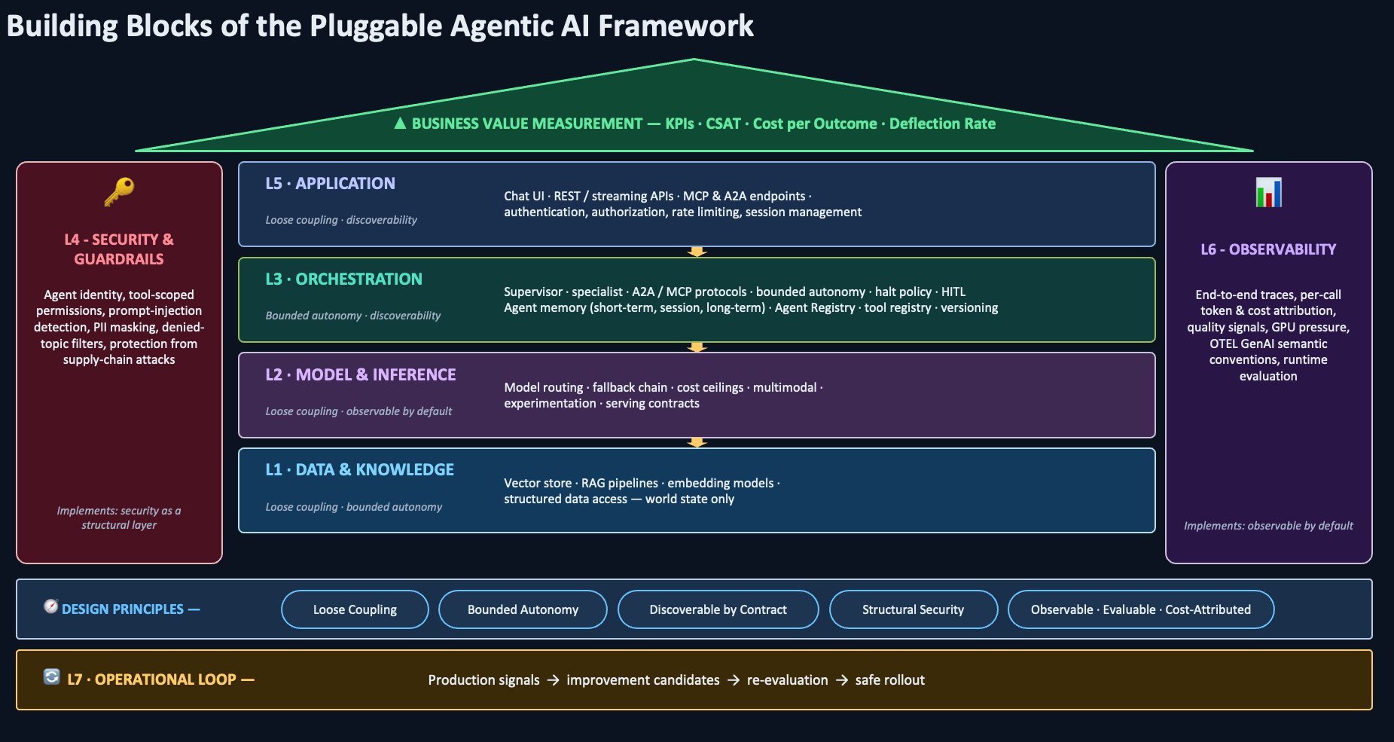
Multi-agent AI systems are systems where multiple specialized agents collaborate under a coordinating supervisor to break down and solve complex tasks that exceed any single agent's effective scope. The seven layers below reflect the architectural decomposition of production-grade agentic AI: a separation of concerns where each layer addresses a distinct failure mode from the previous section and implements one or more of the design principles. The briefs are vendor-neutral — the partner or AWS implementation of any layer is a choice; the contract at each layer boundary is not.

L1 — Data & Knowledge: Grounded Retrieval Over World State

Multi-agent systems require shared, authoritative grounding so every specialist reasons from the same factual base. This layer provides two complementary mechanisms: retrieval-augmented generation (RAG) over unstructured corpora (policies, manuals, documentation) using vector embeddings, and structured data access to transactional sources (orders, customers, inventory). Both serve world state — facts about the domain that exist independently of any conversation. Without this layer, agents fabricate when foundation-model knowledge is incomplete, or specialists drift into inconsistent answers because each builds its own ad-hoc retrieval path. Implements: loose coupling (retrieval is a contract, not an implementation) and bounded autonomy (each specialist declares which knowledge sources it consumes).

L2 — Model & Inference: Right-Sized Model Selection per Workload

Foundation models vary by orders of magnitude in cost, latency, and reasoning capability, and a multi-agent system invokes inference many times per user interaction — once per supervisor decision and once per specialist invocation. Sending every call to the most capable (and most expensive) model is economically and operationally untenable at production scale. This layer addresses this through intelligent model routing — matching each call to the cheapest model that meets the quality threshold for that specific task — and through standardized serving contracts that let the inference provider change without disturbing orchestration. Implements: loose coupling (model provider is swappable) and observable-by-default (per-call cost and latency are first-class telemetry).

L3 — Orchestration: Supervisor–Specialist Coordination, A2A Communication, and Agent Memory

Industry experience and published research converge on a clear pattern: complex tasks are best decomposed across multiple specialist agents coordinated by a supervisor. Anthropic's Building Effective Agents identifies the orchestrator-workers pattern as the canonical structure for tasks where a central LLM dynamically breaks down work and delegates to specialists, and reports that parallel specialist invocation consistently outperforms single-agent approaches on multi-concern problems. The Agent2Agent (A2A) protocol open-sourced by Google — together with the Model Context Protocol (MCP) for tool interoperability — provides standards for agents built on different frameworks to discover, negotiate, and collaborate without exposing internal logic. This layer is what turns a collection of agents into a coherent system.
This layer also owns agent memory — short-term (per invocation), session (per user, across specialists), and long-term (cross-session, cross-user) — because memory scoping, retention, and inter-agent visibility are coordination decisions, not data-access decisions. Which specialist can read or write which memory scope is a bounded-autonomy question that only the orchestration layer can enforce. Implements: bounded autonomy (supervisor routes, specialists execute in scope; memory access is scoped per specialist) and discoverability (agent cards and MCP tool specs are contracts).

L4 — Security & Guardrails: Inference-Time Safety and Bounded Agency

Agentic systems introduce a category of risk that traditional application security does not address: prompts can be manipulated to override instructions (prompt injection), agents with broad tool permissions can take harmful actions (excessive agency), and multi-agent fan-out increases the surface area for both. The OWASP Top 10 for Large Language Model Applications identifies prompt injection (LLM01) and excessive agency (LLM06) as the leading risks and explicitly warns that unchecked autonomy jeopardizes reliability, privacy, and trust. The NIST AI Risk Management Framework similarly requires that AI system risks be managed through documented, enforceable controls. This layer applies inference-time content filters, denied topics, prompt-attack detection, sensitive-data masking, and contextual grounding checks uniformly across all agents, independent of how individual prompts are written. Implements: security as a structural layer; depends on bounded autonomy — guardrails have nothing to enforce on if agents have no bounds.

L5 — Application: Managed Surface for Multi-Channel Agent Delivery

A multi-agent system is consumed by humans through chat interfaces, by upstream systems through APIs, and by partner integrations through MCP- and A2A-compatible endpoints. This layer provides the managed surface that exposes the agent fleet through controlled API patterns: authentication, authorization, rate limiting, session management, and streaming response delivery. Without this layer, every consumer builds its own integration and every agent leaks implementation details through inconsistent interfaces; with it, the same agent fleet serves a chat UI, an internal API, and a partner MCP endpoint from one governed surface. Implements: loose coupling (consumers depend on the surface, not the agents) and discoverability (external endpoints are registry-backed contracts).

L6 — Observability: Distributed Tracing for Distributed Reasoning

A single user interaction in a multi-agent system can generate many LLM calls, tool invocations, and retrieval steps across multiple agents, each contributing to the final response. Diagnosing latency, cost, or quality issues without correlated end-to-end traces is intractable. This layer provides distributed tracing instrumented to GenAI-specific semantic conventions: spans for LLM calls (with token counts, model identifiers, latency), tool calls, retrieval operations, and agent-to-agent handoffs, all correlated by session and trace identifiers. The OpenTelemetry GenAI Semantic Conventions define a vendor-neutral standard for these spans, metrics, and events across providers including Amazon Bedrock, OpenAI, and Anthropic, making it possible to correlate behavior across multi-agent flows regardless of the underlying framework. Modern AgentOps platforms — Amazon CloudWatch GenAI Observability, Datadog LLM Observability, Dynatrace AI Observability, LangSmith, and Arize — all converge on this standard. Implements: observable-by-default. Required instrumentations must be included in every agent from its first deployment.

L7 — Operational Loop: Continuous Evaluation and Feedback-Driven Improvement

Production agentic systems do not remain static. Foundation models are upgraded, prompts are refined, knowledge bases evolve, and traffic patterns shift — and any of these changes can silently regress quality, cost, or latency. This layer provides systematic, continuous evaluation: scoring agent outputs (quality, groundedness, accuracy), comparing performance across model and prompt variations, surfacing low-quality sessions as candidates for knowledge-base updates or fine-tuning, and validating that improvements actually shipped before they reach production traffic. This is where AgentOps closes the loop — the observability telemetry from L5 is not just watched, it is acted on. Implements: observable-by-default (evaluation is a first-class telemetry stream) and reinforces bounded autonomy (regressions are caught per specialist, not per system).

How the layers interlock

The seven layers are a separation of concerns, not a stack of optional add-ons. A request enters at L5, is classified and routed by L3, draws inference from L2 grounded by L1, passes through L4 policy enforcement, emits L5 telemetry at every span boundary, and is continuously evaluated by L7 — whose findings feed corrections back into every layer above it. Each layer exposes a stable contract that the adjacent layers depend on; removing or weakening any one layer breaks the contracts above and below it. Partners extending this workshop plug into the layer their product strengthens — inference providers into L2, observability platforms into L5 and L7, guardrail vendors into L4 — confident that the contracts the rest of the system depends on remain intact.

What this framework is not

To keep the boundaries honest:
- It does not enforce a single orchestration framework — that would violate loose coupling.
- It does not permit unbounded delegation between agents — that would violate both bounded autonomy and the runtime security contract.
- It does not mandate a specific model provider — routing is a contract, not a lock-in.
- It does not replace domain-specific evaluation — it provides the scaffolding into which domain evaluators plug.

Use Case for this workshop

A new customer logs into the AnyCompany Streamlit chatbot. Amazon Cognito is used as identity provider. Amazon Cognito hands back a JWT carrying their identity and tier. The customer types "What's my refund for ORD-10001?" and the chatbot streams the question to the Supervisor Agent — Customer Support (built on Amazon Bedrock AgentCore Harness (Preview)), with their customer ID set as the memory key.
The Supervisor checks Amazon Bedrock AgentCore Memory and finds nothing. It's their first session, so it works only from what's in front of it. It queries the AWS Agent Registry (Preview) to find the right specialists and delegates over A2A. The Order Agent pulls the order from Amazon DynamoDB through the Amazon Bedrock AgentCore Gateway. The Refund Agent then runs three tool calls in turn. It looks up the policy in an Amazon Bedrock Knowledge Base, checks eligibility, and issues a refund with an ETA. The Supervisor runs the date math, applies the customer's tier-based refund rules, and streams the answer back token-by-token. Every hop is traced into Amazon CloudWatch, and on the next visit the Supervisor will already remember the customer's tier and preferences.
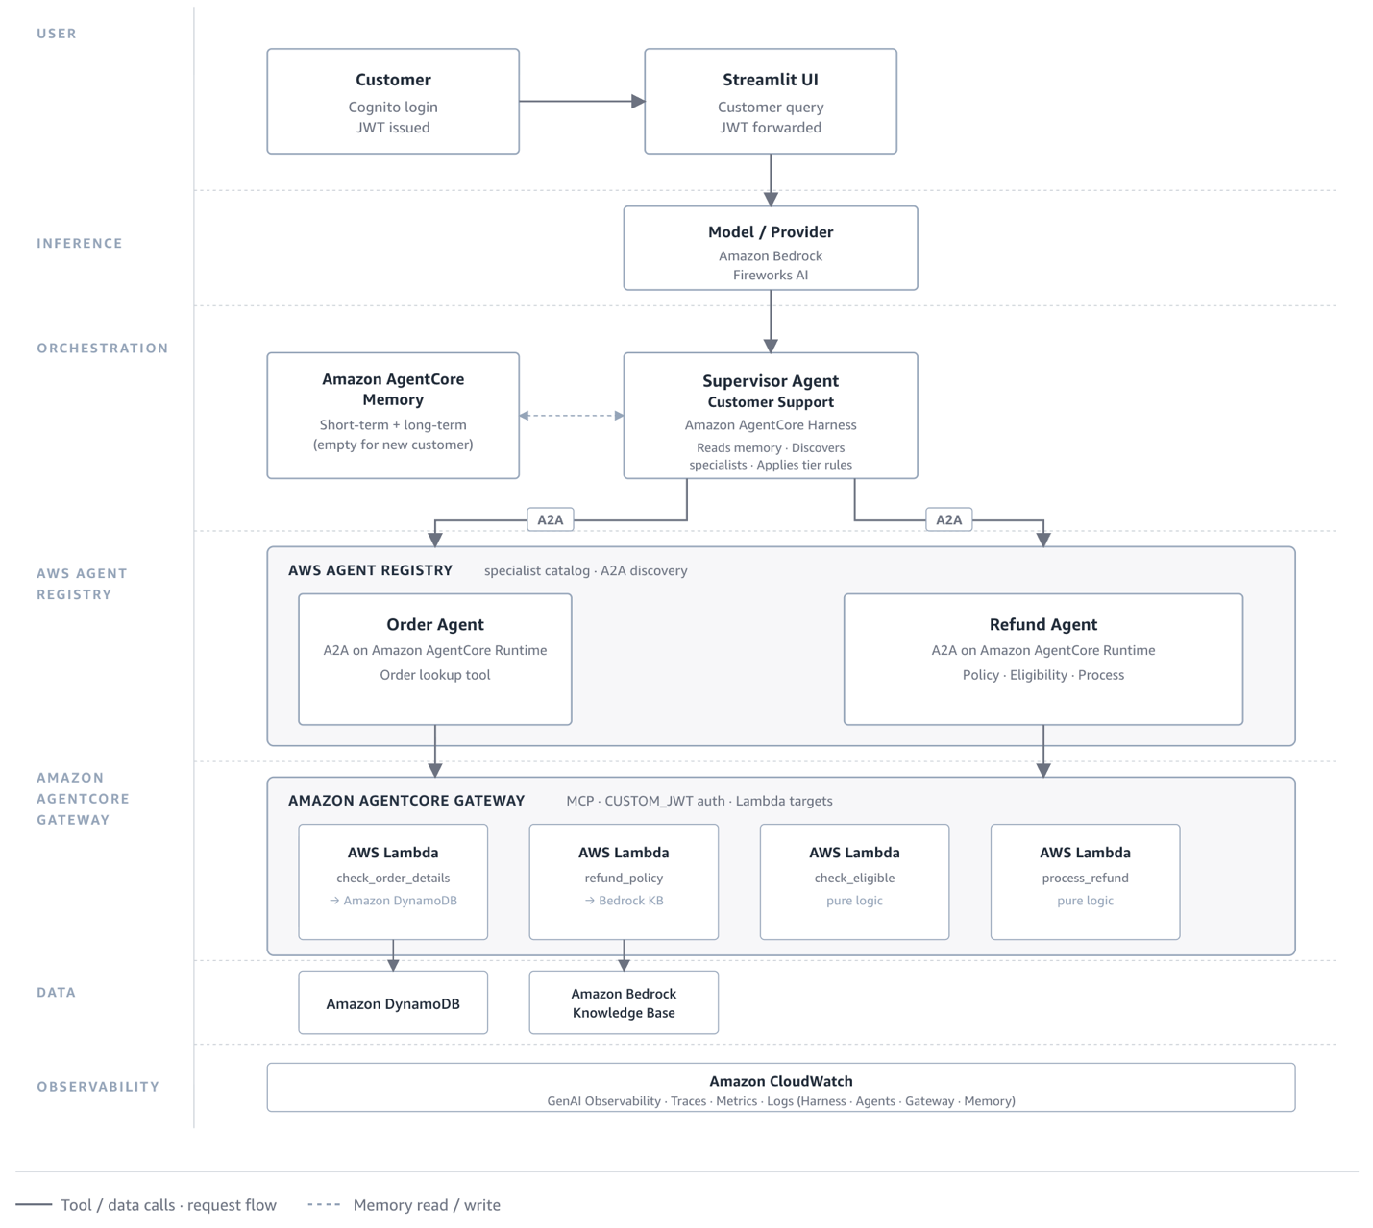

AWS and Partner Extensions

This workshop showcases the better-together story of building enterprise agentic AI reference architectures with AWS and partner technologies working in combination — spanning the full lifecycle of build, deploy, operate, and scale. Each partner extension takes the same AnyCompany retail use case and swaps one or more layers of the base implementation for a partner technology, so participants see how the combined stack behaves as a coherent system rather than as a set of isolated tools.
Participants leave with more than a reference architecture. They leave with take-away implementation code — the notebooks, agents, and configuration for each layer — that they can adapt directly to their own environments. Extensions live under aws-<partner>/ in the repository and are contributed through the process described in Contribution Guidelines.
- Base implementation with AWS
- AWS + Fireworks
- AWS + NVIDIA + Baseten
- AWS + Brave Search + NVIDIA
- AWS + Runway

Prerequisites

In this workshop, you will be reviewing and configuring various AWS services included below.
- Amazon Bedrock
- Amazon Bedrock AgentCore Runtime
- Amazon Bedrock AgentCore Memory
- Amazon Bedrock AgentCore Gateway
- Amazon Bedrock AgentCore Browser
- Amazon Bedrock AgentCore Code Interpreter
- Amazon Bedrock AgentCore Observability
- Amazon Bedrock AgentCore Harness (Preview)
- AWS Agent Registry (Preview)
- Amazon CloudWatch
- AWS Lambda
- Amazon DynamoDB
- Amazon OpenSearch Serverless

Open Source Frameworks

You will also be using the following open source frameworks:
- Strands Agents
- LiteLLM

Who This Workshop Is For

Designed for teams moving from AI experimentation to production deployment who need a validated architecture, direct hands-on experience, and a shared reference framework to coordinate across engineering, platform, and product functions.
Audience | What They Take Away
👨‍💻 AI / ML Engineers | A working multi-agent skeleton using AWS-native services, adaptable to any domain without starting from scratch
👥 Platform & Infra Teams | A governance model for security policy, compute infrastructure, and cost management at scale
📊 Solutions Architects | A proven seven-layer reference pattern that reduces architecture risk and accelerates customer engagements
⚙️ MLOps / DevOps | Deployment, versioning, and observability patterns built specifically for agentic AI systems in production
📋 Technical Leaders | A realistic picture of the build, deploy, and operate lifecycle for production agents and where investment creates the most leverage

Workshop Modules

The workshop is organized into the following modules. Each layer is built on the other and execute in the same order.
- L1 - Data & Knowledge Layer: Provision a multi-modal Amazon Bedrock Knowledge Base on Amazon OpenSearch Serverless and an Amazon DynamoDB orders table for AnyCompany.
- L2 - Model & Inference Layer: Build a pluggable inference layer on LiteLLM with Amazon Bedrock Guardrails, swappable across Amazon Bedrock, Fireworks AI, OpenAI, and Anthropic.
- L3 - Agent Orchestration Layer: Stand up A2A specialists with Strands, an Amazon Bedrock AgentCore Harness (Preview) orchestrator, and the AWS Agent Registry (Preview), Amazon Bedrock AgentCore Gateway, and Amazon Bedrock AgentCore Memory services that glue them together.
- L4 - Security, Safety & Guardrails Layer: Add gurdrails for each tool invocation to verify the tool results againt sensitive data, prompt injection and other configured guardrails
- L5 - Application: Managed Surface for Multi-Channel Agent Delivery
- L6 - Observability & Monitoring Layer: Read end-to-end traces, metrics, and logs across the agent stack in Amazon CloudWatch GenAI Observability.

Supported Regions

This workshop is supported only in us-east-1 (N. Virginia) and us-west-2 (Oregon)

Cost

Running this workshop end-to-end takes between 2 and 4 hours. The total AWS service cost to complete the workshop is less than $5.

Cleanup

The notebooks in each module include cleanup instructions that are commented out by default. Once you complete all the modules, run the cleanup steps in reverse order, from the last module back to the first so that downstream resources are removed before the upstream resources they depend on.

Prerequisites

Overview

This workshop assumes that you have a good understanding of generative AI and are familiar with solutions like Retrieval Augmented Generation (RAG) , AWS services like Amazon Bedrock , Amazon Bedrock AgentCore , Amazon DynamoDB and hands on experience with Python is recommended.
This is going to be an AWS-led workshop
Notebooks that you will run to execute the workshop will be provided for you, we will use Amazon SageMaker AI Studio for easier packaging the development environment (AWS event).
Now, click on the AWS-led workshop link above and get started!

Sagemaker AI Studio
After signing into the AWS account, follow Launch Amazon SageMaker AI Studio instructions to open Amazon SageMaker AI Studio.
Here are the instructions if you are in an AWS-led workshop event:
- Federate into the Amazon SageMaker AI console from the Open AWS console link in the workshop left panel:
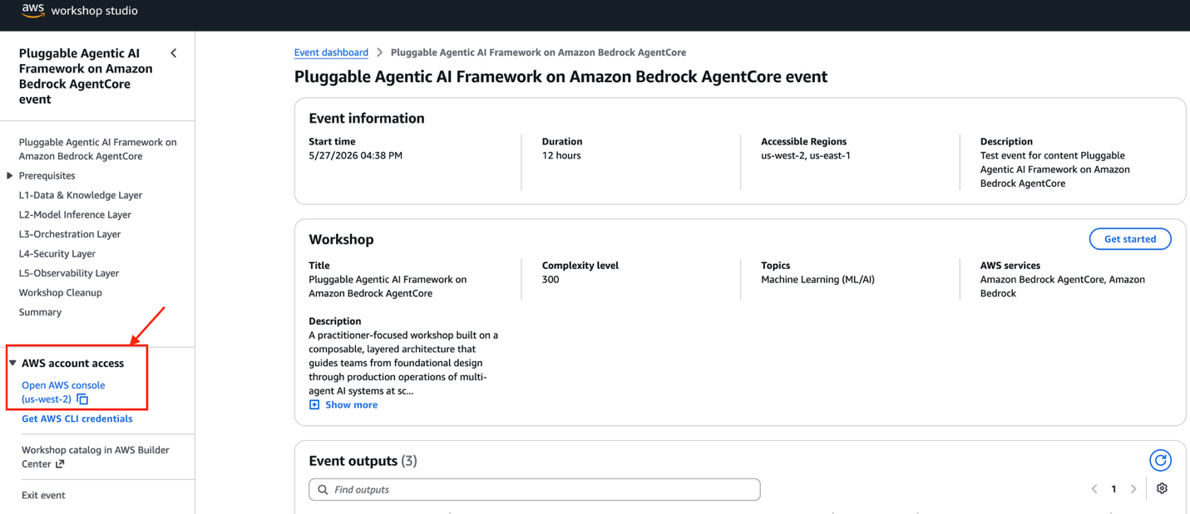
- In AWS console navigate to the Amazon SageMaker AI console, you can do this by simply starting to type SageMaker AI in the search box at the top.
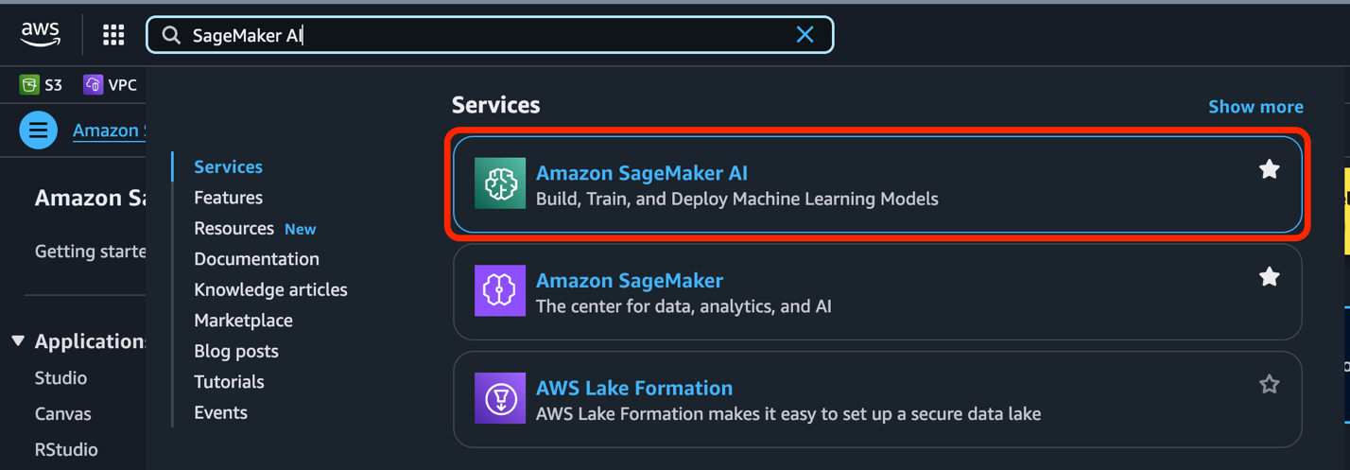
- On the left in the Applications and IDEs section select Studio.
- In the Get started box, make sure the workshopuser is selected and select Open Studio.
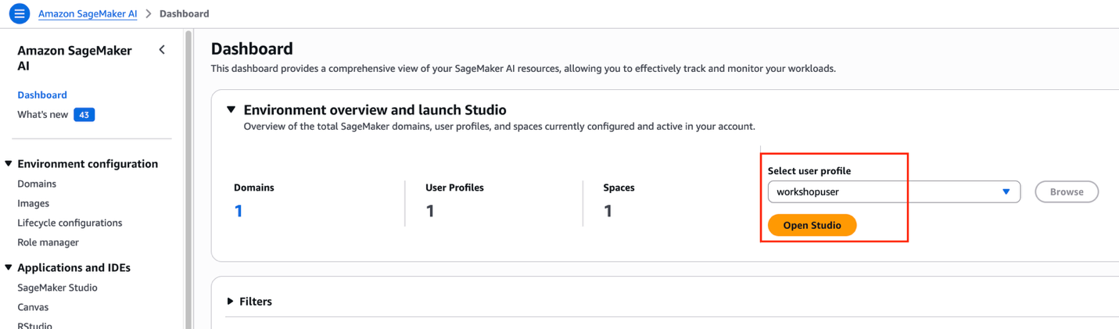
- Once you click on Open Studio, you will be redirected to Amazon SageMaker Unified Studio. Click on the Jupyter Lab icon on top left.
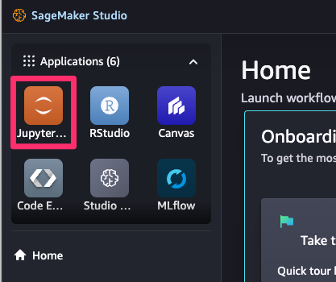
- Click on the "Open" button as shown below
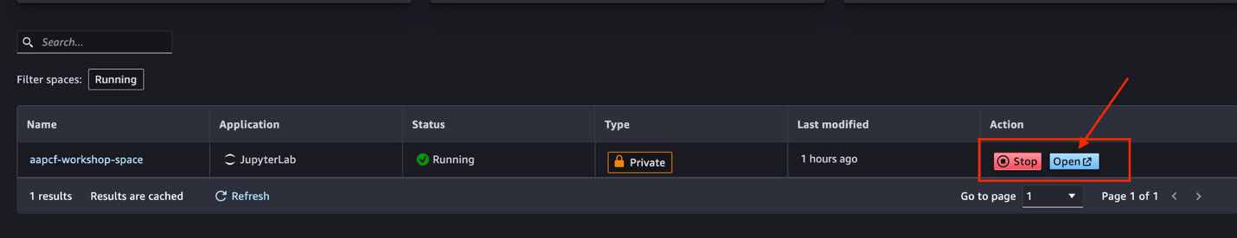
- Jupyter lab will open up with a directory called "pluggable-agentic-ai-framework". This is will contain all the notebooks that we will use for this workshop.
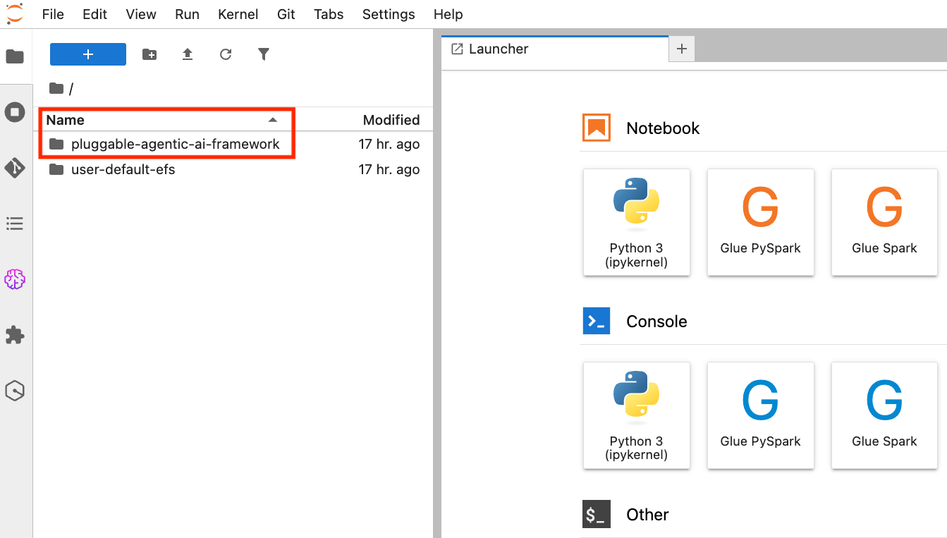

Start the workshop

We are ready to start running the workshop.

Selecting the Kernel

The first time you open up a notebook, you may need to select a kernel. Below are the steps shown for one of the lab:
In the JupyterLab file explorer UI on the left side of your screen, open up the first notebook by navigating to: pluggable-agentic-ai-framework/l1-data-knowledge/1_s3_knowledge_base_setup.ipynb.
Once this notebook is opened up, select the kernel selector button (shown in red).
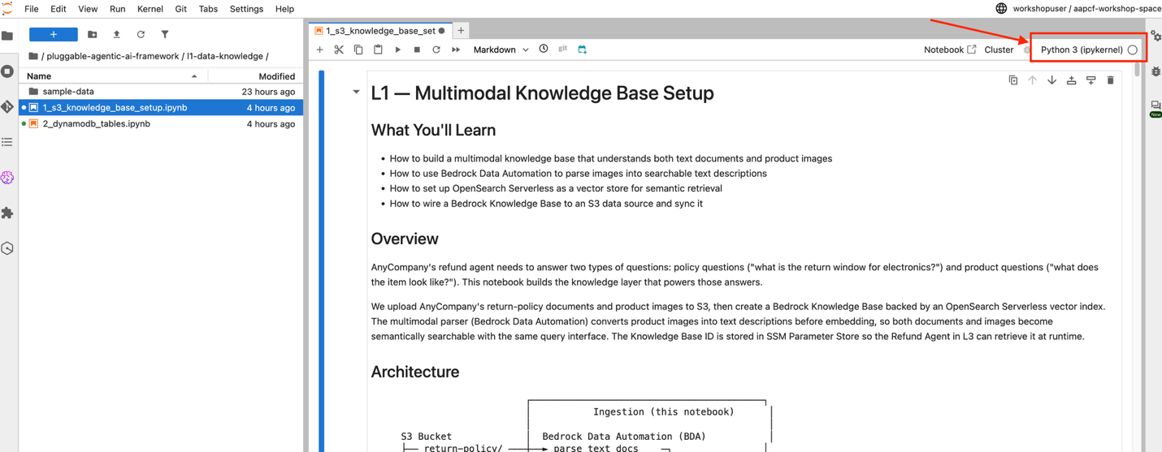
Ensure that the Python 3 (ipykernel) is selected. If not, select it as shown below.
For each notebook in this workshop, please ensure that this Python 3 (ipykernel) is selected before you run the notebook cells.
You're all set! Proceed to 01-Data & Knowledge Layer

AWS + Datadog Implementation
Before you start this section, make sure you have:
- completed the workshop prerequisites, including the Datadog API and Application keys, so your AWS environment, SageMaker notebook, and Datadog credentials are ready.
- read the workshop home page for an overall understanding of the Pluggable Agentic AI Framework, its design principles, and the seven layer contracts.
- reviewed the AWS-only implementation, which is the base version this extension builds on. This extension assumes familiarity with those L1–L7 concepts and describes the layers that change.

AWS and Datadog implementation of the Pluggable Agentic AI Framework

The AWS and Datadog extension replaces the operational plane of the AWS-only base workshop, meaning observability, evaluation, and operations, and complements the deterministic AWS security controls with Datadog's reasoning-based runtime security controls. The framework's layer contracts stay intact throughout. Amazon Bedrock AgentCore continues to supply the managed orchestration, registry, memory, gateway, and application surface, and the supervisor and specialist agents continue to run on Claude Sonnet 4.6 on Amazon Bedrock through LiteLLM. Datadog takes over the three layers where agentic systems are secured, measured, and improved: AI Guard for runtime agent-behavior enforcement at L4, Agent Observability for end-to-end multi-agent tracing at L6, and Evaluations and Experiments for the continuous improvement loop at L7.
By the end of this module you will know how to build a multi-agent AI system on AWS, then secure and operate it with Datadog.

Pluggable Agentic AI architecture with AWS and Datadog

Following the AWS-only base workshop, the Datadog extension builds a multi-agent customer-support system for a fictional retailer on Amazon Bedrock AgentCore. Three agents participate in a single request.
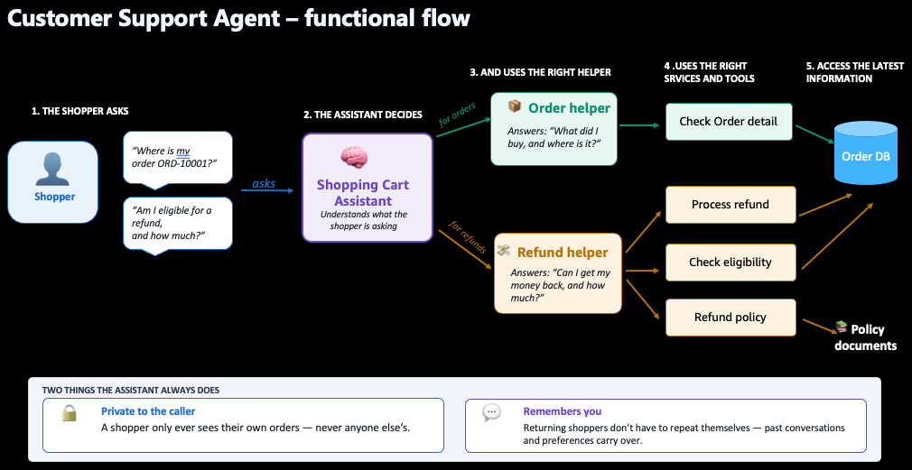
An orchestrator runs on Amazon Bedrock AgentCore Harness (Preview) and decides what to do. It holds no agent endpoints, discovering the specialist agents at runtime through the AWS Agent Registry (Preview) instead. Two specialist agents, the Order Agent and the Refund Agent, are Strands-based agents served over A2A on Amazon Bedrock AgentCore Runtime. They reach their tools through an Amazon Bedrock AgentCore Gateway using MCP, and those tools are AWS Lambda functions backed by an Amazon DynamoDB orders table and an Amazon Bedrock Knowledge Base.
The architectural fact that shapes both observability and security is that these three agents do not share a deployment model. The orchestrator runs on AgentCore Harness, which is AWS-managed, so there is no container to modify and no way to add a process. The two specialist agents run from a container image the workshop builds, so that image can be changed freely.
The Datadog extension swaps three layers of the framework to Datadog: security (L4), observability (L6), and evaluations and operations (L7). Everything else remains AWS-native.
End-to-end request flow
The architecture below shows the base workshop with the Datadog operational plane attached.
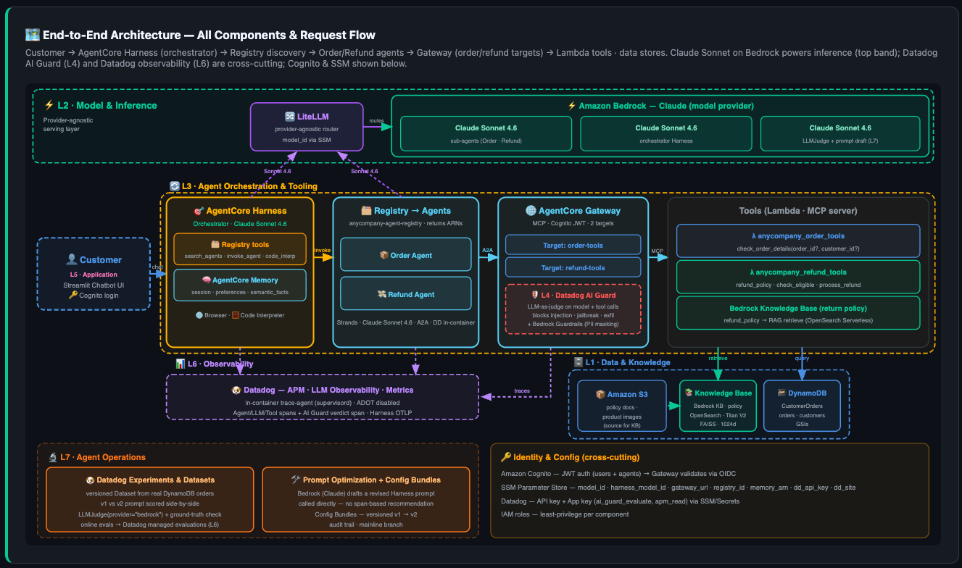

Part 1: L6 - Observability Layer

Answering "why was this answer wrong" or "why did this take 11 seconds" requires one continuous trace across the orchestrator and both specialist agents, plus visibility into the model calls and tool calls inside each. Because the three agents have different deployment models, a single observability backend is reached over two fundamentally different instrumentation paths. W3C trace context propagating across the boundary is what stitches them into one trace.
Overview of Datadog Agent Observability: the Datadog product for monitoring, troubleshooting, and evaluating LLM-powered applications. Every request your application fulfills is represented as a trace, and each trace is made of nested spans, where the first span is the root. A trace can be as small as a single model inference or as large as a dynamic sequence of steps an agent decides on at runtime, which is the shape this workshop produces. Each span carries its name, duration, inputs and outputs, errors, model metadata such as temperature and max_tokens, token metrics, and tags.
Spans are categorized by span kind , which declares the type of work the span performed. The kind also determines whether a span is allowed to be a trace root:
Span kind | Represents | Valid root span
llm | A call to a model | Yes
workflow | A predetermined sequence of operations around one or more model calls | Yes
agent | A dynamic sequence of decisions and operations chosen by the model | Yes
tool | A call to a program or service whose arguments the model generated | No
task | A standalone step with no external call, such as preprocessing | No
embedding | A call that returns an embedding | No
retrieval | A data retrieval against an external knowledge base | No
This workshop uses the agent pattern: a root agent span per invocation with llm and tool spans nested beneath it. Keep the root rule in mind, because it explains a failure mode described later in this module. A tool span is not a valid root, so if the orchestrating agent span is not active when a tool span opens, that span becomes an effective root and is discarded.
On top of tracing, the module uses four capabilities. Out-of-the-box dashboards report cost, latency, performance, and usage trends. Evaluations score quality, privacy, and safety per span. Patterns applies automated hierarchical topic clustering to production traffic, which is how you find coverage gaps and quality drift over time. And Insights analyzes received traces to surface recurring cost and reliability problems, each with a root cause, impact, supporting evidence, and a recommended fix, with no configuration required.

Path one: in-runtime sidecar for the specialist agents

The Order Agent and the Refund Agent deploy onto a custom image containing two processes, the Python agent and a Datadog trace-agent. Amazon Bedrock AgentCore Runtime has no multi-container or sidecar concept, so the sidecar is a second process inside the same image, supervised by supervisord running as PID 1.
The image is built multi-stage. The first stage installs the full Datadog Agent solely to extract one 22 MB binary, the trace-agent, rather than shipping the roughly 650 MB of embedded Python that comes with the complete agent. This keeps the image inside the 2 GB AgentCore Runtime limit.
The custom Dockerfile reaches the deployment by overriding the starter toolkit's Dockerfile generation. The toolkit prefers an existing project-root Dockerfile over its own generated template, so the notebooks stage the sidecar Dockerfile immediately before calling configure() and remove it in a finally block after launch(), so it cannot affect a later deploy.
At container start, entrypoint.sh performs the runtime configuration. It validates that AGENT_MODULE and DD_API_KEY are present and exits non-zero if either is missing. That guard matters, because without it the trace-agent would boot happily and discard every span, producing an agent that serves traffic correctly while emitting no telemetry. The script then points ddtrace at localhost:8126, generates /etc/datadog-agent/datadog.yaml with the APM receiver and the EVP proxy both enabled, and execs supervisord so that process becomes PID 1 and receives shutdown signals directly.
Nothing account-specific is baked into the image. The Order and Refund images are identical, and the AGENT_MODULE environment variable selects which agent runs. All per-agent differentiation arrives through launch(env_vars=...).
supervisord runs the two processes with deliberately asymmetric restart policies. The trace-agent restarts automatically, because telemetry is infrastructure that should always be up and a restart is harmless. The agent does not, because a crash should surface as a failed deployment rather than a silent restart loop that hides a real defect.

The ADOT decision

ADOT, the built-in OpenTelemetry instrumentation in AgentCore, is explicitly disabled by passing disable_otel=True at configure time. This is the pivotal decision in the whole extension.
The reason is that ddtrace conflicts with the opentelemetry-instrument wrapper used by ADOT, and on the ADOT path the native ddtrace security spans are dropped. Those spans carry the Datadog AI Guard verdicts, so losing them would make the security layer invisible in Datadog.
The cost is real and worth stating plainly. No OpenTelemetry spans reach Amazon CloudWatch or AWS X-Ray from these agents. This architecture trades the AWS-native observability path for a single consistent Datadog view, and it also rules out AgentCore evaluators that read OpenTelemetry spans.

Two span channels, one egress

The sidecar carries two distinct channels over one network egress. Ordinary APM spans go to the trace-agent's receiver on port 8126 and out to the Datadog trace intake. LLM Observability spans go to the same trace-agent through its EVP proxy at /evp_proxy/v2/api/v2/llmobs.
This is why LLM Observability is enabled with agentless_enabled=False. Agentless mode would not only redirect LLM Observability spans, it would also switch the APM span writer to the public intake, diverting the security spans off the sidecar that exists to carry them.

Path two: direct OTLP export for the orchestrator

Because the Harness is AWS-managed, it cannot host a sidecar. It exports traces straight to the Datadog OTLP intake instead, configured entirely through OpenTelemetry environment variables set at deploy time.
Four configuration details matter:
- The protocol must be http/protobuf, because the Datadog OTLP intake rejects gRPC.
- Service and environment come from OTEL_SERVICE_NAME and OTEL_RESOURCE_ATTRIBUTES, not from DD_SERVICE and DD_ENV, which the OpenTelemetry exporter ignores.
- Three headers ride on the same exporter: dd-api-key for authentication, compute_stats=true so Datadog derives APM trace metrics from these spans, and dd-otlp-source=llmobs, which runs the GenAI conversion so the same spans also populate LLM Observability.
- OTEL_SEMCONV_STABILITY_OPT_IN opts into the GenAI semantic conventions that the conversion depends on.
Only the trace signal is redirected. The Harness continues sending its logs and metrics to Amazon CloudWatch.

What gets emitted

Three signal types reach Datadog from the specialist agents, and two from the orchestrator.
APM distributed traces give the request path across orchestrator, specialist agent, gateway, and tool Lambda, with the latency contribution of each hop. LLM Observability spans give the agent-internal view. Trace-derived metrics follow from compute_stats and the trace-agent, and they support cost-per-session calculation, monitors, and dashboards, with quality evaluations attached to spans.

How the agent pattern is instrumented

LLM Observability spans are structured as the agent pattern: one root agent span for the whole invocation, with llm spans for model calls and tool spans for tool calls nested beneath it.
The nesting is produced by a Strands HookProvider rather than the usual LLM Observability decorators. The reason is structural. The A2A server drives the agent through agent.stream_async(...), an async generator, which decorators cannot wrap cleanly. So the root agent span opens on BeforeInvocationEvent and finishes on AfterInvocationEvent, with the live span handle stashed in the per-invocation state dict so the paired callback can close it. Tool spans open and close the same way, keyed by tool use ID so concurrent tool calls do not collide.
Model spans require no instrumentation at all. The agent calls Amazon Bedrock through LiteLLM, and the ddtrace LiteLLM integration traces that automatically as an llm span carrying model, provider, messages, and token counts. Because LiteLLM reaches Bedrock over its own signed HTTP client rather than the instrumented boto path, there is no duplicate span.
Two implementation notes are worth keeping for anyone maintaining this. Every observability callback swallows its own exceptions, so a telemetry failure can never break the agent. And tool spans must pass ml_app explicitly, because in the stream_async flow the tool callback frequently does not see the agent span as the active LLM Observability span. That makes the tool span an effective trace root, and a root span without ml_app is silently dropped.

The ML application split

The orchestrator and the specialist agents land in different LLM Observability applications. The orchestrator appears under anycompany-orchestrator, derived from OTEL_SERVICE_NAME. The specialists appear under anycompany-customer-support, set through DD_LLMOBS_ML_APP, and are distinguished from each other within it by per-agent DD_SERVICE values.
The practical consequence is that a delegated request spans two ML applications, and reviewing it end to end requires switching between them. This follows directly from the two instrumentation paths and is the main usability cost of the hybrid approach.

Relationship to the security layer

The security control emits its verdict as a native ddtrace APM span named ai_guard, which rides the same sidecar egress. That produces a separation worth stating explicitly: enforcement is independent of telemetry. The AI Guard SDK calls the evaluator API directly, so blocking works whether or not the sidecar is healthy. The sidecar is what makes each verdict visible in the Datadog AI Guard console. The Datadog documentation confirms this split, noting that without the Datadog Agent the evaluator API still works but the traces are not visible.
Viewing those spans additionally requires a retention filter on resource_name:ai_guard at 100%, since they would otherwise be sampled away.

Part Two: L4 - Agent Security

The workshop implements defense in depth across four controls that fail in different ways and catch different things: identity and authorization at the perimeter, deterministic data sanitization on tool output, probabilistic threat detection inside the agent runtime, and containment that survives the individual request. Two are AWS-native, two are Datadog. The design intent is that no single control is load-bearing.

Control one: identity and authorization

Authentication is Amazon Cognito, with two distinct paths because the human and the service need different tokens.
The human path runs through the Streamlit chatbot using USER_PASSWORD_AUTH against a public app client. Token handling here is done properly: the application fetches the pool JWKS through a cached PyJWKClient and calls jwt.decode with the signing key, algorithms=["RS256"], an explicit audience, and an explicit issuer, so signature, algorithm, audience, issuer, and expiry are all verified before any claim is read. Two custom claims carry authorization-relevant data, custom:customer_id and custom:tier.
The service path exists because Cognito ID tokens from USER_PASSWORD_AUTH carry no OAuth scope, so a user token is rejected by the tool gateway with 403 insufficient_scope. The specialist agents therefore obtain their own token through the OAuth2 client_credentials grant against a machine-to-machine app client holding the scope anycompany-gateway/invoke, defined on a Cognito resource server.
The tool gateway enforces this with a CUSTOM_JWT authorizer whose allowedClients list contains only the machine-to-machine client ID and whose allowedScopes contains only that scope, validated against the pool's OpenID discovery document. A user token cannot reach the tool gateway at all. The separate Harness gateway, which fronts the registry search and invoke tools, uses AWS_IAM instead.
Authorization on the AWS side is scoped tightly. The gateway execution role grants lambda:InvokeFunction on exactly three function ARNs. Each tool Lambda role is scoped to its own log group and its own data store. The specialist agent Runtime roles follow the AWS-documented least-privilege template for AgentCore Runtime, with the two statements that genuinely require Resource: "*", X-Ray and CloudWatch metrics, constrained by a namespace condition where possible.
At the data layer, the order tool Lambda requires customer_id on every call and uses it as the DynamoDB partition key, which closes an earlier cross-customer leak where an order-ID-only lookup through a global secondary index could return any customer's order. See the gaps section for the limit of this protection.

Control two: data sanitization with Bedrock Guardrails

L2 creates a Bedrock Guardrail with two policies. A single content filter on PROMPT_ATTACK at HIGH input strength with action BLOCK, input only. And a sensitive-information policy covering nine entity types, all with action ANONYMIZE: credit card, US SSN, password, AWS access key, AWS secret key, email, phone, name, and address. A version is published immediately and both the guardrail ID and version are written to SSM Parameter Store.
L4 notebook 1 then attaches a Lambda interceptor to the AgentCore Gateway on the RESPONSE interception point. The interceptor reads the MCP gateway response, and only when the request method is tools/call does it pass the response text through bedrock-runtime.apply_guardrail with source='OUTPUT' and outputScope='FULL', writing the masked text back into the MCP response envelope. Other MCP methods such as initialize and tools/list pass through untouched.
The effect is that PII in tool output is redacted before it reaches the orchestrator, and therefore before it can reach the model context or the user. The chatbot adds a second, cruder layer: a regex pass over streamed text deltas that masks SSN, 16-digit card, and email patterns.

Control three: threat detection with Datadog AI Guard

AI Guard is an LLM-as-judge that evaluates a conversation and returns ALLOW, DENY, or ABORT along with a reason, a list of attack-category tags, and sensitive-data findings. It catches what a deterministic content filter structurally cannot: prompt injection, jailbreak, system-prompt extraction, destructive tool calls, and data exfiltration intent.
It is integrated as a custom Strands HookProvider in the specialist agent runtimes, evaluating at four checkpoints. BeforeModelCall screens the prompt before inference. AfterModelCall screens the model's output. BeforeToolCall screens the pending tool call before it executes. AfterToolCall screens the tool's output, which is the checkpoint that catches indirect injection arriving through data.
The block mechanism differs per checkpoint because Strands exposes a different writable field on each event.
Checkpoint | Block mechanism | Effect
BeforeModelCall | event.cancel | Graceful, model never called
BeforeToolCall | event.cancel_tool | Graceful, tool never runs
AfterToolCall | overwrite event.result | Poisoned output never reaches the model
AfterModelCall | re-raise AIGuardAbortError | Hard halt, no safe substitute exists
Every checkpoint calls evaluate with block=True, but that does not hardcode enforcement. Per Datadog's documented contract, block=True raises only when the server-side service policy for that service has blocking enabled. The real switch is the policy in the Datadog console, set per service and environment, which means posture changes take effect with no redeploy. L4 notebook 4 walks through setting the two agent services to Block mode, tuning evaluation sensitivity, and optionally adding a named-tool blocklist.
One consequence of that design is worth recording: notebook 4 is a console walkthrough containing no executable code, so this part of the security posture lives in Datadog configuration rather than in the repository. It is neither version-controlled nor reproducible from a fresh clone, and if the policies are left in Monitor mode the enforcement scenarios in notebook 5 will not block.
The failure posture is closed in three places. An API or network error on evaluate blocks the call. A failure in the conversation converter is inside the same boundary and also blocks. And in Monitor mode, where the lock write is the only containment action available, a failed write escalates to an inline block.
Two further implementation details are worth noting. Both the AI Guard imports and the Strands event classes are imported lazily, after the agent module has already imported Strands, because an eager module-level import captures different class objects than the ones the agent loop dispatches on, and the callbacks then silently never fire. And both Before checkpoints set a flag in the per-invocation state when they block, because the paired After event still fires after a graceful cancel; without the flag the hook would evaluate twice, double-count signals, and risk a duplicate lock write.
The workshop uses a hand-written hook rather than Datadog's first-party AIGuardStrandsPlugin, which was available at the pinned library versions. The reason is the next control: the canned plugin blocks per call but has no way to take a custom side effect on a verdict.

Control four: containment with a cross-agent circuit breaker

The capability a per-call guardrail cannot express is stopping an actor rather than a request. On a high-severity verdict the hook writes a LOCK row to a DynamoDB risk table keyed on the agent's principal, and a second Gateway interceptor on the REQUEST interception point then returns 403 on every subsequent tool call from that principal, across agents and across sessions, until the lock expires.
The trip condition is deliberately narrow. An ABORT always trips. A DENY trips only when it carries the tags data-exfiltration and jailbreak together, which is the lethal-trifecta signature. This separates three cases cleanly: a benign bulk order lookup tags data exfiltration alone and stays a per-call block, a lone prompt injection tags jailbreak alone and stays a per-call block, and only the combination escalates.
The REQUEST interceptor reads the lock with ConsistentRead=True so a lock release is visible on the very next call, and it performs its own read-time TTL comparison rather than trusting DynamoDB's deletion latency. A lock hit returns a JSON-RPC error with code -32002 and HTTP 403.
The trust model is the most interesting property. The lock write is the workshop's own deterministic Python executing under the Runtime IAM execution role, not an action the model can choose. A prompt-injected agent never reaches that code path and never touches the credentials. The lock key is the sub claim of the machine-to-machine token, and the enforcing interceptor derives the same sub independently from the inbound Authorization header, so neither side passes the key to the other.
There is also a runtime kill switch for testing. A __breaker_config__ row in the same table toggles enforcement without a redeploy, and the check is fail-safe to enabled: a missing row, a malformed row, or a DynamoDB error all leave the breaker on. Only an explicit enabled=false disables it.

How the controls compose

Threat | Control that catches it | Mechanism
Unauthenticated access | Cognito plus gateway authorizer | CUSTOM_JWT, scope-restricted, M2M client only
PII leaking to the user | Bedrock Guardrails | RESPONSE interceptor, apply_guardrail, ANONYMIZE
Prompt injection in user input | Datadog AI Guard | BeforeModelCall, graceful cancel
Indirect injection in tool output | Datadog AI Guard | AfterToolCall, result overwritten
Destructive or unauthorized tool call | AI Guard, plus tool blocklist | BeforeToolCall, cancel_tool
System-prompt extraction | AI Guard, plus Bedrock PROMPT_ATTACK | DENY at model checkpoint, or input BLOCK
Repeat abuse after one bad verdict | Circuit breaker | DynamoDB LOCK plus REQUEST 403
The division of labor is that Bedrock Guardrails handle sanitization deterministically, AI Guard handles intent probabilistically, and the breaker converts a detection into containment.
L4 notebook 5 exercises this with four scenarios: a clean order lookup expected to pass both checkpoints, a prompt-injection attempt expected to be denied before inference, a destructive bulk-refund request expected to be denied before the tool runs, and a data-exfiltration request expected to trip the breaker. Because AI Guard verdicts are produced by an LLM judge and are therefore non-deterministic, the notebook also seeds a lock directly so the 403 enforcement path can be demonstrated reliably.

Part Three: Agent Evaluation and Operations (Layer 6 and Layer 7)

Evaluation in this track is carried by two notebooks. l6-observability/4_datadog_quality_evaluations.ipynb scores what production actually produced, and l7-agentic-operations/2_datadog_experiments.ipynb decides whether a proposed change is an improvement.

Online evaluation: scoring live output

L6 notebook 4 evaluates a real interaction with the deployed system. It enables LLM Observability in agentless mode. It invokes the live Harness inside hand-constructed LLMObs.agent and LLMObs.llm spans and calls LLMObs.export_span to capture the trace and span identifiers that evaluations will attach to.
Three scoring mechanisms are followed: in the first two, the workshop computes a score and submits it, and Datadog stores, displays, and alerts on it. In the third, Datadog computes the score itself.
A Bedrock LLM-as-judge runs at temperature 0.0 against a strict JSON rubric, returning a verdict of answered, refused, blocked, or error, plus relevance and faithfulness scores and a one-sentence reason. Results reach Datadog through LLMObs.submit_evaluation, the verdict as a categorical metric and the two scores as numeric, with scores omitted when the judge returns null.
A deterministic ground-truth check runs alongside it, exploiting the fact that ORD-10001 is known to be delivered, and submits ground_truth_match and faithfulness_exact.
A managed evaluation then demonstrates the reverse direction. Language Mismatch is a zero-model evaluation that Datadog runs server-side on arriving spans with no judge model to configure. The notebook emits two spans, Spanish in with English out to fail and English with English to pass, and Datadog grades them. This path carries a hard prerequisite the notebook flags clearly: managed evaluations must be created in the Datadog UI first, there is no API for it, and they grade only spans that arrive after they exist.
The most considered piece of design is that both the judge rubric and the deterministic check are AI Guard aware. If the security layer denied a tool response, a naive substring match would record faithfulness=0.0, scoring a successful security block as a quality failure. Both evaluators test for denial markers first and record blocked instead. That is a false-negative class most evaluation harnesses get wrong, and getting it right matters more here than in most systems precisely because Part Two's controls are designed to fire.

Offline experimentation: deciding whether a change helps

L7 notebook 2 turns a prompt revision into a measured comparison.
The dataset is built from real DynamoDB rows for one customer, producing seven records, two questions each across three orders plus one aggregate count. Ground truth is read directly off the rows rather than hand-authored, so the dataset cannot drift from the data, and Datadog datasets are versioned so a run always references a known snapshot.
The experimental design is sound in one specific respect worth calling out. The task function receives (input_data, config) and reads its system prompt from config, which makes the prompt the independent variable: the same function runs twice and the only difference between the two runs is one configuration key. The task also attaches Prompt Tracking metadata, so the two runs populate Agent Observability Prompts keyed by version, giving a text diff and per-version latency, token, and cost figures alongside the scores.
Three evaluators are applied identically to both runs.
Evaluator | Type | What it measures
StringCheckEvaluator(operation='icontains') | Deterministic, built-in | Whether the ground-truth value appears in the answer
LLMJudge(provider='bedrock') | LLM-as-judge | Clarity and completeness, scored one to 10, passing at seven
GroundTruthPassRate | Custom summary evaluator | Fraction of records passing the deterministic check
Running deterministic and judge-based evaluators together is deliberate. The string check is objective but brittle, since a correct answer phrased unusually can fail it. The judge handles phrasing but is itself a model and can be inconsistent. Running both means a regression in one is visible against the other.
The baseline experiment reads its prompt live off the deployed Harness. The candidate experiment reads its prompt from the configuration bundle, with two useful guards: it raises if no candidate is found, and it raises if the candidate is identical to the baseline, which would otherwise silently compare a prompt against itself. Both run twice over the dataset to average out non-determinism, with records evaluated concurrently.
The interpretation guidance is the sharpest line in either notebook, and it is the part most worth carrying into other work: a candidate that wins on the judge but loses on the ground-truth check is more fluent and less accurate, which for a support agent is worse rather than better. Promotion is identified as the only mutating call in the flow and is deliberately left for a human to run.

What is measured, and what is not

Four evaluator archetypes appear across the two notebooks: deterministic code-based checks, a hand-rolled LLM-as-judge, the framework-provided LLMJudge, and Datadog-managed server-side evaluation, plus a custom summary aggregator. As a taxonomy for teaching the subject, that is complete.
Four limits should be stated plainly, three of which the notebooks acknowledge themselves.
The L7 experiment evaluates a prompt, not an agent. The task calls Bedrock converse directly rather than invoking the Harness, justified on speed, seconds against roughly two minutes, and on isolating the prompt from tool selection. The consequence is that registry discovery, delegation, memory, guardrails, and AI Guard all sit outside the measurement. The notebook offers the full-agent variant as a documented extension.
The L6 evaluations attach to a notebook-constructed span that wraps the Harness invocation, not to the deployed specialist agents' own LLM Observability spans. Those agent-emitted spans are a separate stream and receive no evaluations, so the scores describe the orchestrator's output as observed from outside rather than the agents' internal behavior.
The dataset is seven records drawn from a single customer, and the managed-evaluation demonstration runs on synthetic spans rather than real traffic.
And the whole layer is notebook-driven and manual. There is no automated regression gate, so nothing prevents a prompt change from shipping unmeasured.

What participants will learn from running through the AWS and Datadog workshop.

How a supervisor agent can delegate without knowing its specialists exist. Participants deploy two Strands specialist agents as A2A servers on AgentCore Runtime, publish them to an AgentCore Registry, and give the orchestrator Harness only a search tool and an invoke tool. They observe the orchestrator discovering an agent at request time and delegating to an ARN it was never configured with, then reaching tools through an AgentCore Gateway over MCP with a Cognito machine-to-machine token rather than a hardcoded endpoint.
How to instrument agents when you do not control every runtime. Participants deploy the specialist agents onto a container image carrying an in-process Datadog trace-agent, and separately route the AWS-managed orchestrator straight to Datadog's OTLP intake, since a managed Harness has no container to modify. They observe a single continuous trace spanning both paths, and learn why ADOT must be disabled to get there: ddtrace collides with AgentCore's opentelemetry-instrument wrapper, which silently drops the security spans the later labs depend on.
How agent-internal behavior becomes queryable telemetry rather than log archaeology. Participants attach a Strands hook provider that opens an agent span per invocation with tool spans nested beneath it, then watch the llm spans appear without any instrumentation, emitted by the LiteLLM integration. They learn why decorators cannot wrap an A2A agent driven by stream_async, then turn those traces into derived metrics, cost per session, monitors, a dashboard, a Service Map, and an SLO.
How two guardrail technologies compose because they fail differently. Participants attach a Bedrock Guardrail as a Gateway response interceptor that anonymizes PII deterministically, then enable Datadog AI Guard as an LLM-as-judge evaluating four checkpoints inside the agent. They observe an email address masked in a tool response and a prompt injection denied before inference, and learn why a content filter cannot judge intent and a judge cannot guarantee redaction, so neither control replaces the other.
How to turn a detection into containment that outlives the request. Participants trip a circuit breaker: a high-severity verdict writes a lock row to DynamoDB, and a Gateway request interceptor then returns 403 on every subsequent tool call from that principal, across both agents and across sessions. They examine why the lock is unforgeable, since the write is deterministic code running under the Runtime IAM role rather than an action the model can choose, and see why the trip condition requires two attack tags together so a benign bulk lookup does not lock out real users.
How security posture becomes a configuration change rather than a deployment. Participants enable AI Guard on running agents with an environment update and no image rebuild, because the hook ships present and env-gated. They then flip enforcement between monitor and block in the Datadog service policy with no code change at all, and exercise a runtime kill switch that is fail-safe to enabled, so a missing or unreadable config row leaves protection on.
How to validate controls against real attacks, and what a probabilistic control cannot promise. Participants run four scenarios, a clean lookup, a prompt injection, a destructive bulk-refund request, and a data-exfiltration attempt, and identify which control catches each, mapping to OWASP LLM01 prompt injection, LLM02 sensitive information disclosure, and LLM06 excessive agency. They also confront the honest limit: AI Guard verdicts come from an LLM judge and are non-deterministic, so the lab seeds a lock directly to demonstrate the enforcement path reliably.
How to score what production actually did, and who is computing the score. Participants evaluate a real interaction three ways: a Bedrock LLM-as-judge returning a verdict with relevance and faithfulness, a deterministic ground-truth check, and a Datadog-managed evaluation that runs server-side with no judge model to configure. They learn to make the scoring rubric security-aware, since a response blocked by AI Guard must record as blocked rather than as a faithfulness failure, which is a false negative most evaluation harnesses produce by default.
How to decide whether a change is an improvement rather than just different. Participants build a versioned Datadog dataset from real order rows so ground truth cannot drift, then run two experiments where the system prompt is the only variable, scored by the same deterministic check, the same LLM judge, and the same summary evaluator. They learn to read the result as a decision rather than a verdict: a candidate that wins on the judge but loses on the ground-truth check is more fluent and less accurate, which for a support agent is worse.

© 2008 - 2026, Amazon Web Services, Inc. or its affiliates. All rights reserved.

